Lab 7: File Operations | September 14, 2026
Name: Qimin Zhu ID: 6888143
Paste screenshots of the results for each question.
- Using file utility
  - Create an empty file named test1
  - Run command: echo Hello World > test2
  - Create a directory named dir1
  - Use the command file to see the file type of test1, test2, and dir1
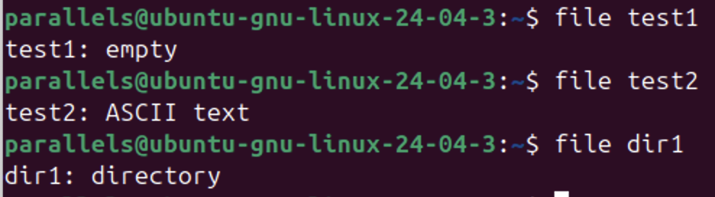
  - Use the command file to see the file type of /bin/xz

- Create two text files named config_v1.txt and config_v2.txt with the following content:

config_v1.txt (Original Version):
# Configuration File
setting1=enabled
setting2=auto
setting3=low

config_v2.txt (Modified Version):
# Configuration File
setting1=disabled
setting2=manual
setting3=low

You can create those files with nano or run the following commands instead:
echo -e "# Configuration File\nsetting1=enabled\nsetting2=auto\nsetting3=low" > config_v1.txt

echo -e "# Configuration File\nsetting1=disabled\nsetting2=manual\nsetting3=low" > config_v2.txt

Use the diff command to compare both files and answer the following questions:
- What differences do you see between config_v1.txt and config_v2.txt?
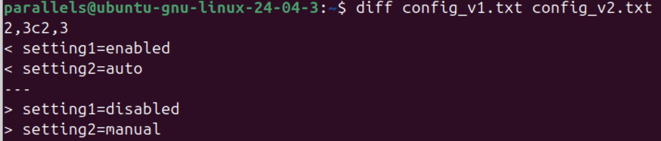
- What command can you use to generate a unified diff format? (Try option -u)
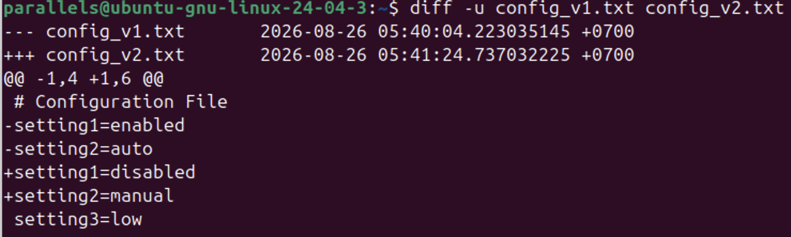
- How can you save the differences into a patch file and apply that patch to config_v1.txt?
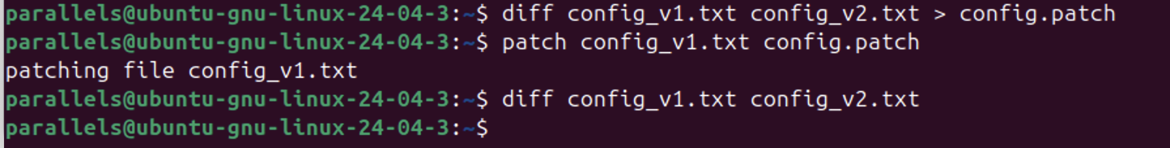

- Now assume a third developer also made changes to the file. Create config_v3.txt:
config_v3.txt (Another Modified Version):
# Configuration File
setting1=enabled
setting2=manual
setting3=high

Use diff3 to compare config_v1.txt, config_v2.txt, and config_v3.txt. Identify any conflicting changes.
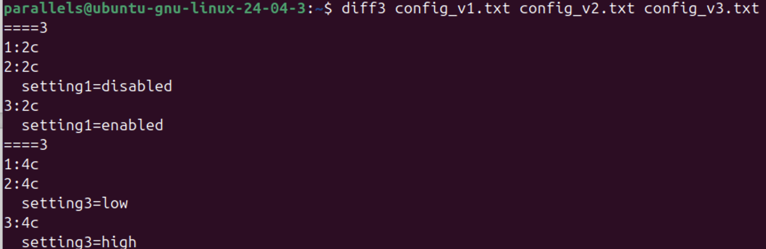

- Create a sample 10 MB text file by running this command:
for i in {1..440000}; do echo "Hello World Line $i"; done > sample.txt
Use gzip, bzip2, xz, and zip to compress sample.txt file, and use the command ls -lh to compare the sizes (No captured screens needed).
  - Size of gzip file = gzip sample.txt
  - Size of bzip2 file = bzip2 sample.txt
  - Size of xz file = xz sample.txt
  - Size of zip file = zip sample.txt

- TAR command
- Using tar, backup all files and subdirectories under your home directory. Place the resulting tarball file in the /tmp directory, giving it the name backup.tar.
tar -cvf /tmp/backup.tar ~
- Accomplish the same task with gzip compression using the -z option with tar, creating /tmp/backup.tar.gz.
Tar -cvzf /tmp/backup.tar.gz ~
- Make backups using the -j option with bzip2 compression, and -J option with xz compression.
Tar -cvjf /tmp/backup/tar.bzip2 ~
Tar -cvJf /tmp/backup/tar.xz ~

- Compare the size of all four backup files.

